Outline

Equine Influenza

1). Causes
- Infected animals
- strains on the influenza virus type A

2). Symptoms

- Coughing
- Nasal discharge
- Lameness
- High fever
- Swelling

3). Treatment - should give swine vaccination to prevent
- NO specific treatment
- eat, drink & administer non-steroidal anti-inflammatory drugs

4). Facts
- Highly contagious (how to contain it)
- Disinfect/ sterilize
- Follow protocols

5). Prevention
- vaccinate
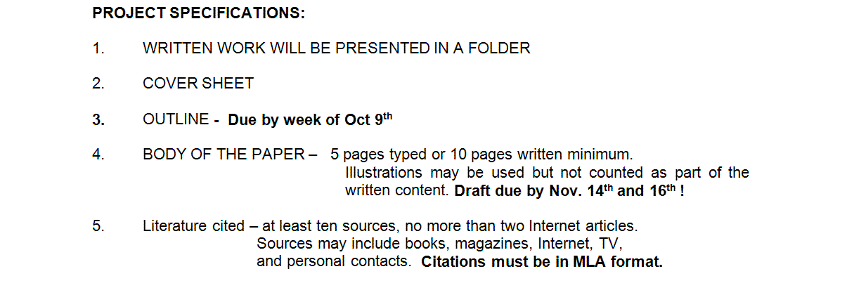
- management

